# **ANALYSIS OF TWO DECADES OF USE OF SIMPLE ANIMAL MODELS FOR BIOMEDICAL RESEARCH IN AFRICA**

S. K. Hamidu1,4,7, U. Ahmad 5, M. Zaid 2,3,4, , F. E. Nasr 4,6, A. Alkhamis3,4 A. M. Ganga3,A. A. Ladan 11,12, A. Ahmad7 , M. M. Mailafiya M. Umar R. Abdulazeez 4,7

S. R. Issa2,4, W. A. Olalekan M. B. Maina 2,3,4,*

1 Department of Human Anatomy, Faculty of Basic Allied Medical Sciences, Gombe State University, Gombe, Nigeria.

2 Sussex Neuroscience, School of Life Sciences, University of Sussex, Brighton, UK

3. Biomedical Science Research and Training Centre, College of Medical Sciences, Yobe State University, Damaturu, Nigeria.

4 TReND in Africa (www.TReNDinAfrica.org), Brighton, UK.

5 Department of Anatomy, Faculty of Basic Medical Sciences, Bauchi State University, PMB 65 Gadau, Nigeria.

6 Faculty of Science, Alexandria University, Alexandria, Egypt.

7 Ahmadu Bello University Zaria, Kaduna, Nigeria

**Correspondence: MBMaina m.bukar-maina@sussex.ac.uk**

# **ABSTRACT**

Simple model systems such as *Drosophila*, Zebrafish, and *C. Elegans* have enabled several breakthroughs in understanding human health and disease. Their conserved biological processes, ever-expanding established procedures for handling, and amenability for molecular and genetic manipulation, in addition to the ethical concerns in using vertebrate models have made these models preferred in several life science disciplines globally. Our recent analysis of work revealed that most African neuroscience laboratories use wild-type rodents and rarely use transgenic and simple models. To what extent these models are used in other disciplines across Africa is not known. In addition to their several advantages, owing to their cheap maintenance cost, the adoption of simple model systems will help to bridge the scientific research gap between Africa and the Global North. Here, we sought to understand to what extent *Drosophila*, Zebrafish, and *C. Elegans* are used in African science by analyzing scientific publications from African laboratories from 2000 to 2021. Out of 1851 PubMed-indexed publications, 168 used at least one of the models. at 37 – 40 articles per country, South Africa, Nigeria, Kenya, Egypt, Morocco, and Tunisia contributed 75% of these studies. The remaining 25% were contributed by seven other countries at 2-7 articles per country. From here, we extract and analyze information on funding and international collaboration. The results revealed that: Funding was declared in 68.45% of the studies. 24.4 % were locally funded, 28.57 % were internationally funded, and 15.5% received both local and international funding. On international collaboration, 48% of the studies had collaborations however only 11.9% were internal(with other African countries). The remaining collaborations were mostly with European countries.

# **INTRODUCTION**

Africa is home to over a billion people with the world's largest genetic diversity1. This diversity is important for disease susceptibility or resistance, manifestation, and the body’s response to factors that may improve the quality of life. The continent accounts for 25% of the global disease burden2 yet, contributes less than 1% of global scientific output3 (Re The continent depends on scientific solutions or innovations from the West, which may not necessarily be compatible with the African people. For these reasons, Africans need to also work on developing homegrown solutions consistent with their problems. Unfortunately, African scientists are significantly challenged for many reasons, including low funding, career development programs, lack of access to laboratory infrastructure, and good science policies4,5.

Some of the challenges affecting African scientists can be resolved by the choice of research model systems. Most African basic scientists used mice and rats for their research5,6 which are expensive to maintain and less genetically amenable than many invertebrate and lower vertebrate model systems. Most biological processes in higher animals are largely conserved in many invertebrates7. Scientists have taken advantage of this to advance understanding of the physiology and pathology of human body systems. One of the most widely used organisms is the fruit fly (*Drosophila melanogaster*), which belongs to the Drosophilidae family. It has been one of the most popular, widely studied organisms for over a century, especially in the field of genetics8 neuroscience9, developmental biology10, and as a model of human disease 11–13. Interestingly, many *Drosophila* species exist in the wild in Africa that are not yet fully studied14. After its significance as a model was proposed in 1948 15, *Caenorhabditis elegans* (C. Elegans) also became popular and widely accepted by scientists globally, especially in the field of genetics and neuroscience. It shares many similar advantages with *Drosophila*16–18 with the additional benefit of having comparatively simpler biology, a shorter life cycle, and is cheaper to maintain19. Zebrafish (*Danio rerio*) is another model that has become popular since its introduction in the 70s20. It has several advantages over other models in the field of developmental biology21. For example, its brain and other sense organs develop in less than 24 hours in a transparent embryo. Moreover, it can be bred in large numbers within a short period. In addition to the above, these simple model systems have several advantages over other models, including mice and rats, due to their affordability and ever-expanding established procedures for handling and amenability to genetic manipulation 22.

The many advantages offered by simple models, especially affordability, will help bridge the gap between African science and the Global North. To what extent these models are used in Africa is unknown. Nonetheless, raising awareness of the advantage of using simple models will advance science in Africa and other low-resource settings. Using our recently described methodology that identifies only African-led research5, this study seeks to characterize the African-led biomedical research in the past 20 years to ascertain to ehat extent *Drosophila*, *C. Elegans*, or Zebra fish were used as model organisms5. We specifically assessed the type of model organisms used in research, its frequency, the discipline in which the research was conducted, who funds the research, and the availability of any local or international collaboration. This revealed that: there is need for more campaign on adoption of simple animal model, improvement on collaborations among scientists working with the models especially intra-collaborations. Also, a satisfactory access to fundings for simple animal model studies was observed.

# **Method**

## Literature Search

To assess the use of the invertebrates model in African-based laboratories, we modified our previous strategy5 which involves manual data extraction of articles retrieved from PubMed. The data were procured in comma-delimited format (CSV) using the following search terms (((((((Drosophila) OR (fruit fly)) OR (fruit flies)) OR (Caenorhabditis)) OR (C. Elegans)) OR (*Caenorhabditis Elegans*)) OR (zebrafish)) OR (*Danio rerio*)) AND (Name of African country). The search terms were repeated for all 54 African countries and details of 1721 articles were downloaded. Unfortunately, the data does not give the basic information (the study location, funding declaration, collaboration e.t.c.) needed to achieve the objectives of this study. To obtain this information and exclude the articles that do not satisfy the inclusion criteria (Table 1) manual data extraction was done.

## Table 1 Inclusion and exclusion criteria

|  |
| --- |
| Exclusion |
| Review articles |
| Irrelevant articles e.g. those without abstract or full text |
| Studies done outside the country being analyzed |
| Articles that have no abstract or full-text in English |
| When it is not clear whether work was done in that country or abroad and the corresponding author is not based in the country |
| When it is not clear whether work was done in the country even if the author is from Africa, as long as they are collaborating with institutions abroad |
| Inclusion |
| Studies from Africa in which fruit flies (Drosophila, Peach fruit flies, and Mediterranean fruit flies), C Elegans, or zebrafish were used as a model organism |
| Studies done in African laboratories even if the senior author or corresponding author is based outside Africa |

## Data Extraction

The manual data extraction was done by retrieving full texts or at least the abstracts of the articles and the details of the model organism, institutions of affiliation, and funding were extracted.

## **Data Analysis**

The data were analyzed using anaconda navigator jupiter notebook for python 3.8. Data exploration was done using pandas, geopandas, and matplot library. Data visualization was carried out using Seaborn library, geoplots, and altaire packages.

# **Results**

## **Number of publications between 2000 and 2020 from Africa using invertebrate models**

Out of the 1851 studies using *Drosophila*, *C. Elegans*, or Zebra fish, whose detail were downloaded from PubMed, only 168 (9.10%) were conducted in African-based laboratories. An upward trend is observed in the number of publications most especially in the last five years (Fig 2b). However, there is still a need for the campaign to encourage the adoption of invertebrate models as the number of publications from the continent is very low compared to outputs from the Global North.

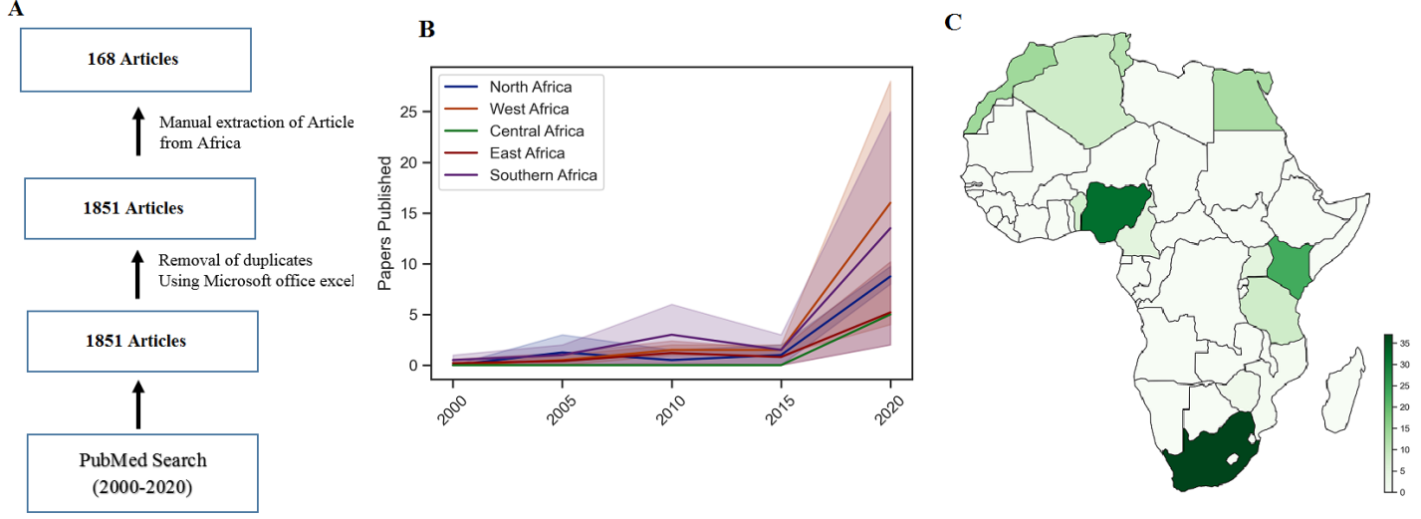

**Figure 1:**  **Study design and publication trends**. (a) Workflow for articles retrieval and inclusion strategy. (b) Total publication per year (c) choropleth for the number of publications by country.

75% of the studies were conducted in six (6) countries (Fig. 2). These are: South Africa (n = 37, 22.0%), Nigeria (n = 32, 19.0%), Kenya (n = 23, 13.7%), Egypt (n = 13, 7.0%) Morocco (n = 10, 7.7%), and Tunisia (n = 11, 6.5%). At 2-7 articles per country eight other countries contributed the remaining articles: Tanzania (n = 8, 4.8%), Algeria (n = 8, 4.8%), Cameroon (n = 5, 3.0%), Benin Republic (n = 7, 4.2%), Uganda (n = 5, 2.9%), Mauritius (n = 2, 1.2%), Zimbabwe (n = 2, 1.2%) and Mozambique (n = 1, 0.6%). By region, central Africa seems to lag behind, having only six studies from Cameroon. In addition, studies from the southern part of the continent were mainly from South Africa and the majority of West African studies were from Nigeria.

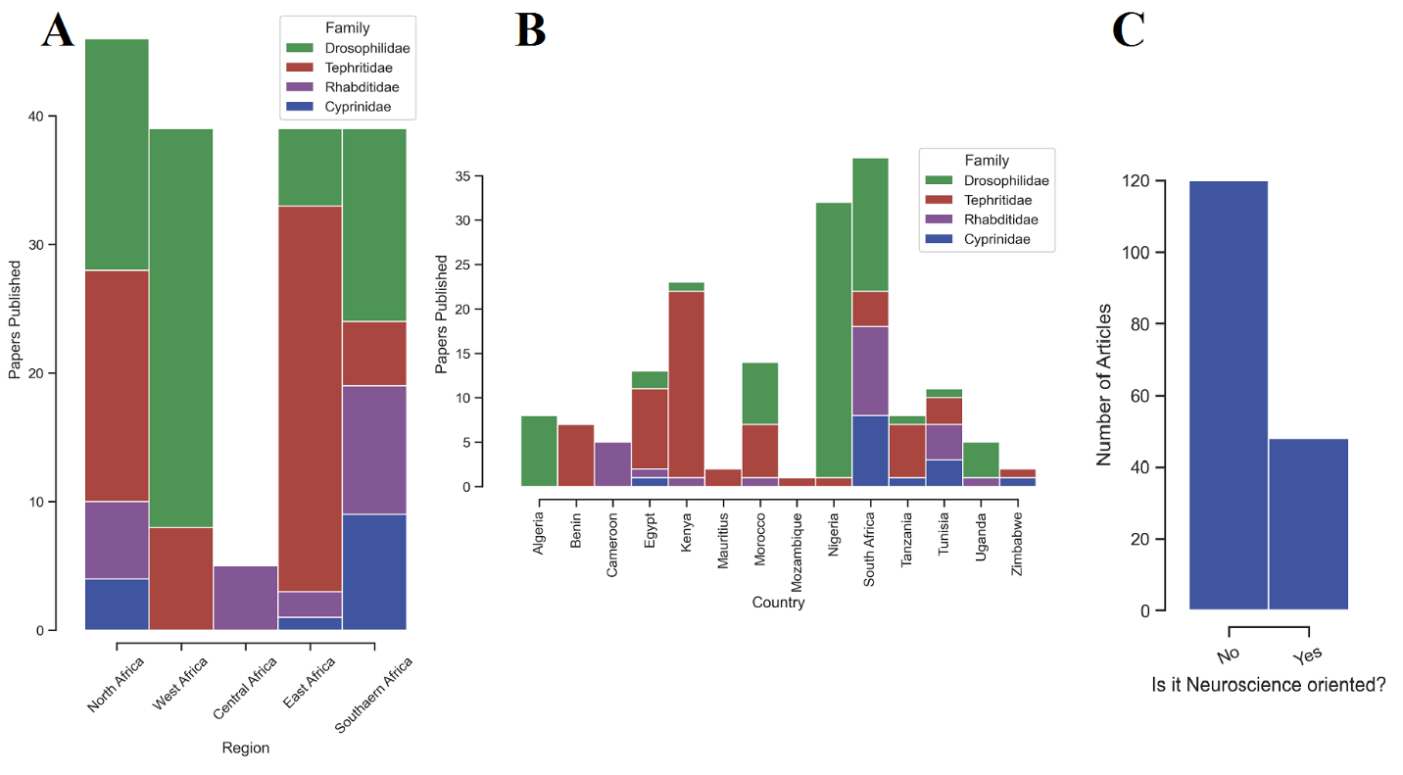

**Figure 2: Total publications by region and country and neuroscience relation** (a) Total publications by region by the model organism. (a) Total publications by country by the model organism (c) Total publications by neuroscience relation.

Given that these models are mostly used for neuroscience research23 we categorized the articles into neuroscience and non-neuroscience-related. Surprisingly only about 32% (n=54) of the studies were neuroscience-related. Other disciplines in which these models were used are mostly in the areas of general toxicities, reproductions pest control. This finding perhaps indicates one area in which the application of neuroscience can be used in environment-friendly strategies for plant protection.

Research funding

Although some publishers do not require funding declaration and most African scientists do not usually acknowledge funding, 67.9% (n=114) of the studies acknowledged funding and over 60% of the funds came from international organizations. The top international funders (countries) who contributed over 70% of the total funding are European countries, specifically: Germany (n=20, 30%) Italy (n=9, 13.9%), Austria (n=5, 7.6%). By organizations, the most frequently acknowledged funders are The World Academy of Sciences (TWAS) (n=7, 10.9%), The International Atomic Energy Agency (n=5, 7.6%), and the German Academic Exchange Service (n=7,10.9%). By local funding, the most frequently acknowledged funders are the National Research Foundation (NRF) of South Africa (n=19, 28.8%), ICIPE, Kenya (n=7, 10.6%), and the National Fund for Scientific Research Algeria (n=6, 9.1%). It is noteworthy that all the studies from the southern part of the continent were conducted in South Africa and all the studies were locally funded. This affirms the previously reported5 positive progress of South Africa’s policies on research development.

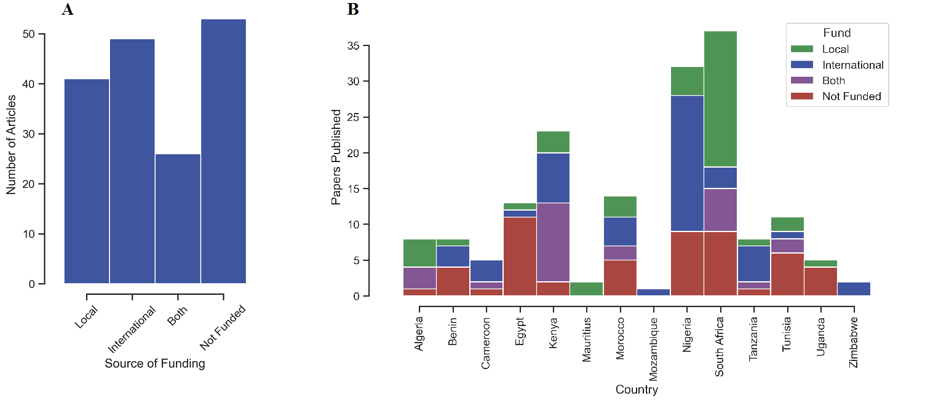

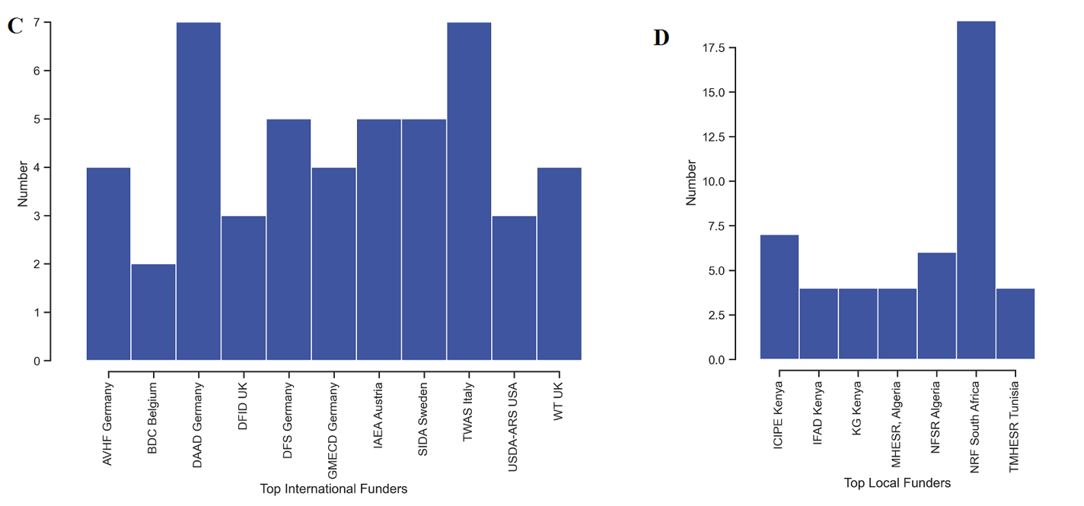

**Figure 3:** Source of funds for studies between 2000 and 2020 from Africa using the simple model. (a)Number of Articles by Funding Status (b) Funding status by country (c) External funders by organization (d) Internal funders by organization

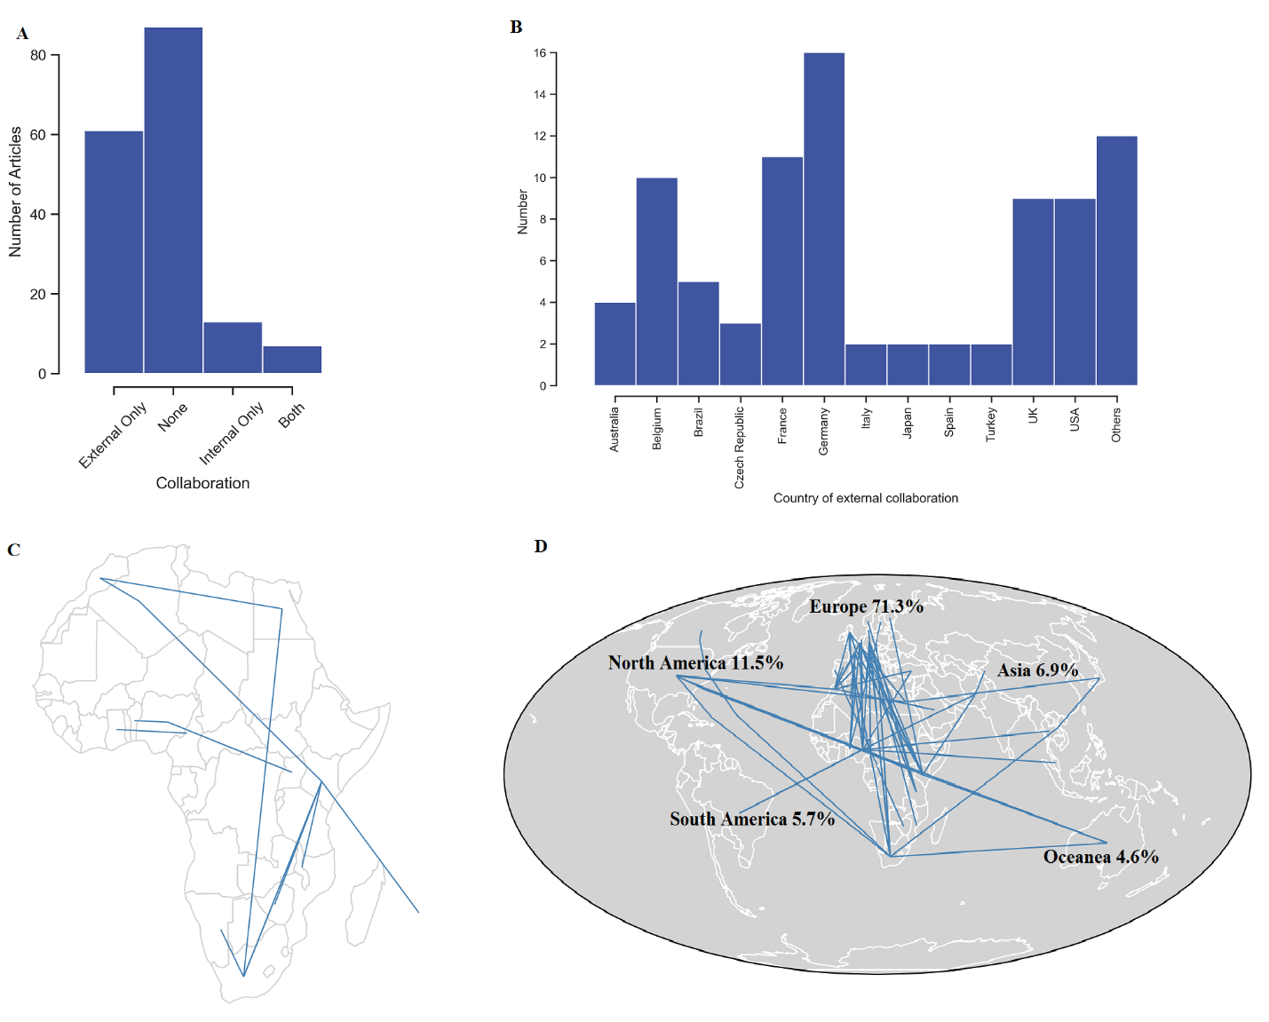

**Figure 4: Collaborative structure for studies between 2000 and 2020 from Africa using the simple model.** (a) Number of Articles by collaboration status (b) Top external collaborators (Countries) (c) Sankey diagrams showing the internal collaboration. (d) Sankey diagrams showing the external collaboration.

By international collaborations, more than half (n=87, 51.8%) of the African-based studies using the invertebrates model did not have contributions from any other country. Only 13 studies (7.7%) had a collaboration with another African country. Beyond this, all other collaborations were external, mostly with European countries. This suggests a low collaborative culture among African scientists and calls for the promotion of intra-collaboration among them.

**Discussion**

The publication trend using invertebrate models agrees with the previous studies5,24 demonstrating that the scientific output from the continent is mostly dominated by the six top contributors; South Africa, Nigeria, Kenya, Egypt, Morocco, and Tunisia. This is not surprising because most of these countries rank among the top economies in the continent25,26. Also, South Africa has always been at the top in contributions to science because the standards of education and research in the country are higher compared to other African countries, and the South African health research policy27 identified and reduced the funding gap in health research by earmarking 5% of international development aid agencies project and that of program aid for the health sector to biomedical research. Nigeria’s rank as the second-highest contributor to studies using invertebrate models may also be attributable to the activities of many organizations, including the Neuroscience Society of Nigeria (NSN), TReND in Africa (www.TReNDinAfrica.org), and DrosaAfrica (www.drosafrica.org) who frequently organize workshops and awareness campaigns to foster enthusiasm in the use of simple model systems. This could be the reason why more than 80% of the studies from Nigeria were neuroscience-related. The TReND in Africa has also equipped many African scientists with skills and technology in neurogenetics, genome editing, behavioral neuroscience, and electrophysiology among others through workshops, donation of equipment and consumables, and the establishment of biomedical research centers28,29. Nigeria is one of the top beneficiaries of TReND programs.

The performance of Kenya which was not ranked among the top of Africa’s strongest economies may be due to the presence of the International Centre of Insect Physiology and Ecology (ICIPE) which is one of the major institutes for insect research in the continent. Looking at the total number of publications from the continent, it can be deduced that despite the numerous advantages of using invertebrates as model organisms including cost-effectiveness, which can enable scientists to answer a complex research question at a low cost compared to the vertebrate models, these models are yet to be adopted in Africa. One of the primary reasons for the low scientific outputs from Africa is inadequate funding 5,24,30 and this might be because the continent has the lowest GDP per capita. Moreover, most of the African countries invest less than 1% of their total GDP on research development despite African Union’s recommendation. It can be observed from this study that the funding for invertebrates studies in Africa mostly comes from external sources and this revealed the need for the scientist to engage policymakers, philanthropists, and charitable organizations in Africa to support invertebrates studies because it will advance science in the continent. It is also important to note that for the continent to establish a sustainable invertebrates research environment local funding must be greatly improved because local funders usually have a better understanding of the problems their societies are facing and are expected to select and fund more relevant studies. At the moment South Africa is the only country with more than half of its simple models’ studies locally funded and this is reflective of the fact that the country invests over 0.8% of its GDP (highest in the continent) in research development and this could be the reason why six South African universities ranked among the top ten universities in Africa31.

On international collaborations, this study clearly portrays the room for improvement in intra-collaboration among African countries because an interdisciplinary approach is the best approach to efficiently address complex problems32. For instance, a scientist working on pest or vector control in the field of agricultural science can develop the capacity to diverge into neuroscience to be able to develop more environmentally friendly methods of vector and pest control.

## REFERENCES

1. Campbell, M. C. & Tishkoff, S. A. African Genetic Diversity: Implications for Human Demographic History, Modern Human Origins, and Complex Disease Mapping. doi:10.1146/annurev.genom.9.081307.164258.

2. Simpkin, V., Namubiru-Mwaura, E., Clarke, L. & Mossialos, E. Investing in health r&d: Where we are, what limits us, and how to make progress in africa. *BMJ Glob. Heal.* **4**, 1–8 (2019).

3. Charon, D., Mohamed, A. & Lucia, S. Africa generates less than 1% of the world’s research; data analytics can change that. *Elsevier Connect* https://www.elsevier.com/connect/africa-generates-less-than-1-of-the-worlds-research-data-analytics-can-change-that (2018).

4. Kumwenda, S. *et al.* Challenges facing young African scientists in their research careers: A qualitative exploratory study. *Malawi Med. J.* **29**, 1 (2017).

5. Maina, M. B. *et al.* Two decades of neuroscience publication trends in Africa. *Nat. Commun. 2021 121* **12**, 1–10 (2021).

6. Maina, M. B. *et al.* African neuroscience on the global stage: Nigeria as a model. *Eur. J. Neurosci.* **49**, 1544–1551 (2019).

7. Fernandez, M. P., Rittschof, C. C. & Sierralta, J. A. Invertebrate Neuroscience: Contributions From Model and Non-model Species. *Front. Behav. Neurosci.* **15**, 155 (2021).

8. Hales, K. G., Korey, C. A., Larracuente, A. M. & Roberts, D. M. Genetics on the Fly: A Primer on the Drosophila Model System. *Genetics* **201**, 815–842 (2015).

9. Bellen, H. J., Tong, C. & Tsuda, H. 100 years of Drosophila research and its impact on vertebrate neuroscience: a history lesson for the future. *Nat. Rev. Neurosci. 2010 117* **11**, 514–522 (2010).

10. Tolwinski, N. S. Introduction: Drosophila—A Model System for Developmental Biology. *J. Dev. Biol.* **5**, (2017).

11. Cheng, L., Baonza, A. & Grifoni, D. Editorial Drosophila Models of Human Disease. *Hindawi BioMed Res. Int.* **2018**, (2018).

12. Pandey, U. B. & Nichols, C. D. Human Disease Models in Drosophila melanogaster and the Role of the Fly in Therapeutic Drug Discovery. *Pharmacol. Rev.* **63**, 411 (2011).

13. Mirzoyan, Z. *et al.* Drosophila melanogaster: A model organism to study cancer. *Front. Genet.* **10**, 51 (2019).

14. Sprengelmeyer, Q. D. *et al.* Recurrent Collection of Drosophila melanogaster from Wild African Environments and Genomic Insights into Species History. *Mol. Biol. Evol.* **37**, 627–638 (2020).

15. Dougherty, E. C. & Calhoun, H. G. Possible Significance of Free-living Nematodes in Genetic Research. *Nat. 1948 1614079* **161**, 29–29 (1948).

16. Schrimpf, S. P. *et al.* Comparative functional analysis of the Caenorhabditis elegans and Drosophila melanogaster proteomes. *PLoS Biol.* **7**, 0616–0627 (2009).

17. Gao, R. & Li, J. J. Correspondence of D. melanogaster and C. elegans developmental stages revealed by alternative splicing characteristics of conserved exons. *BMC Genomics* **18**, 1–17 (2017).

18. Ez-Ventoso, C., Vora, M. & Driscoll, M. Sequence Relationships among C. elegans, D. melanogaster and Human microRNAs Highlight the Extensive Conservation of microRNAs in Biology. *PLoS One* **3**, 2818 (2008).

19. Leung, M. C. K. *et al.* Caenorhabditis elegans: An Emerging Model in Biomedical and Environmental Toxicology. *Toxicol. Sci.* **106**, 5–28 (2008).

20. Ferris, H. & Hieb, W. F. Ellsworth C. Dougherty: A Pioneer in the Selection of Caenorhabditis elegans as a Model Organism. *Genetics* **200**, 991–1002 (2015).

21. Veldman, M. B. & Lin, S. Zebrafish as a Developmental Model Organism for Pediatric Research. *Pediatr. Res. 2008 645* **64**, 470–476 (2008).

22. Invertebrates Animal Model - an overview | ScienceDirect Topics. https://www.sciencedirect.com/topics/biochemistry-genetics-and-molecular-biology/invertebrates-animal-model.

23. Sattelle, D. B. & Buckingham, S. D. Invertebrate studies and their ongoing contributions to neuroscience. *Invert. Neurosci.* **6**, 1–3 (2006).

24. Balogun, W. G., Cobham, A. E., Amin, A. & Seeni, A. Using invertebrate model organisms for neuroscience research and training: an opportunity for Africa. *Metab. Brain Dis. Balogun WG, Cobham AE, Amin A, Seeni A. Using Invertebr. Model Org. Neurosci. Res. Train. an Oppor. Africa. Metab Brain Dis 2018 335 [Internet]. 2018 May 24 [cited 2021 Dec 28];33(5)1431–41. Ava* **33**, 1431–1441 (2018).

25. EMMANUEL, A. B. 10 richest African countries in 2021 based on gross domestic product (GDP) | Business Insider Africa. https://africa.businessinsider.com/local/markets/10-richest-african-countries-in-2021-based-on-gross-domestic-product-gdp/yd784tx (2021).

26. Gil-Alana, L. A., Mudida, R. & Zerbo, E. GDP per capita IN SUB-SAHARAN Africa: A time series approach using long memory. *Int. Rev. Econ. Financ.* **72**, 175–190 (2021).

27. P, N. *et al.* *HEALTH RESEARCH POLICY IN SOUTH AFRICA*. https://www.gov.za/sites/default/files/gcis_document/201409/healthresearch0.pdf (2001).

28. Yusuf, S., Baden, T. & Prieto-Godino, L. L. Bridging the Gap: establishing the necessary infrastructure and knowledge for teaching and research in neuroscience in Africa. *Metab. Brain Dis.* **29**, 217–220 (2014).

29. Karikari, T. K., Cobham, A. E. & Ndams, I. S. Building sustainable neuroscience capacity in Africa: The role of non-profit organisations. *Metab. Brain Dis.* **31**, 3–9 (2016).

30. Abd-Allah, F. *et al.* Neuroscience research in Africa: Current status. *eNeurologicalSci* **3**, 7–10 (2016).

31. University Rankings - Africa 2022. https://www.scimagoir.com/rankings.php?sector=Higher+educ.&country=Africa.

32. 5 ways that collaboration can further your research and your career | For Researchers | Springer Nature. https://www.springernature.com/gp/researchers/the-source/blog/blogposts-life-in-research/benefits-of-research-collaboration/17360752.